**Happiness Ranking- Machine Learning**



*Its an indexation of happiness based on survey results, that was first used in 2012 World Happiness Report. In the survey, the respondents were asked to rate their happiness on a scale from 0 to 10. The happiness Index is calculated by averaging the survey results of respondents.*

*This inspired the happiness council to devise their own definition of happiness index, which was coined in the 2012 World Happiness Report.*

**Aim**- Building a machine learning model to predict Happiness Ranking. We will build a machine learning model using Simple linear regression model and train that model using the Happiness index dataset.

**Steps to be taken in the project:**

Step-1: Importing all the necessary libraries of python and machine learning

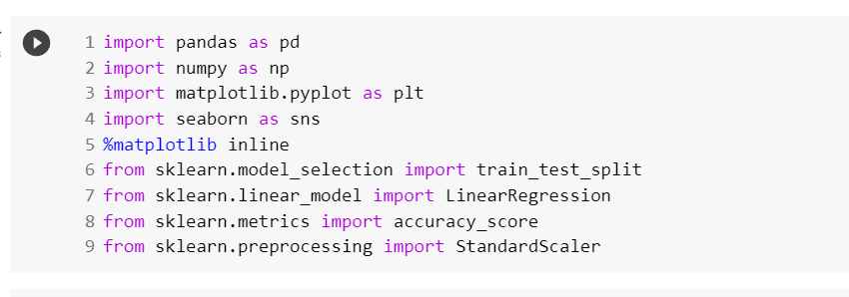

Step-2: Loading the csv-dataset in variable name “happy” from drive

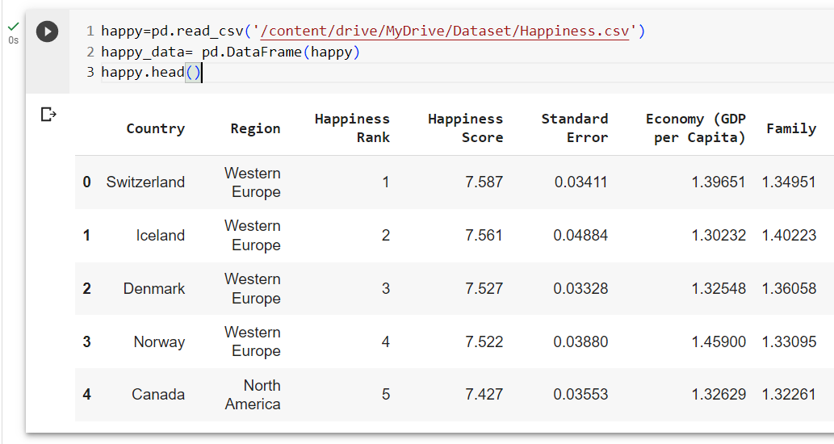

Step-3: Understanding the data using shape(), describe()

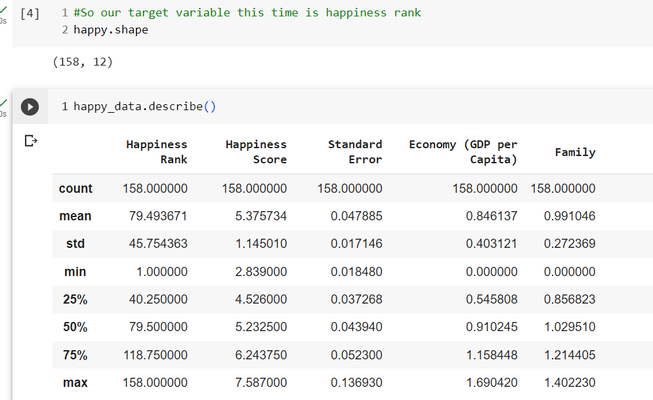

Step-4: Determining Null values using isnull() function

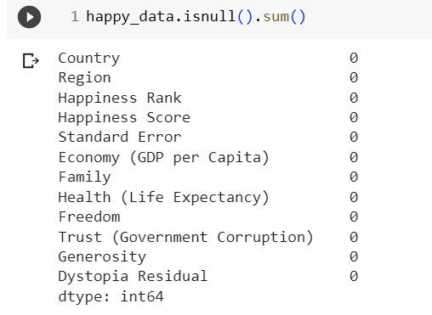

As we can see there is no null value in the dataset so data is considered to be clean.

Step-5: Detecting Outliers by using boxplot

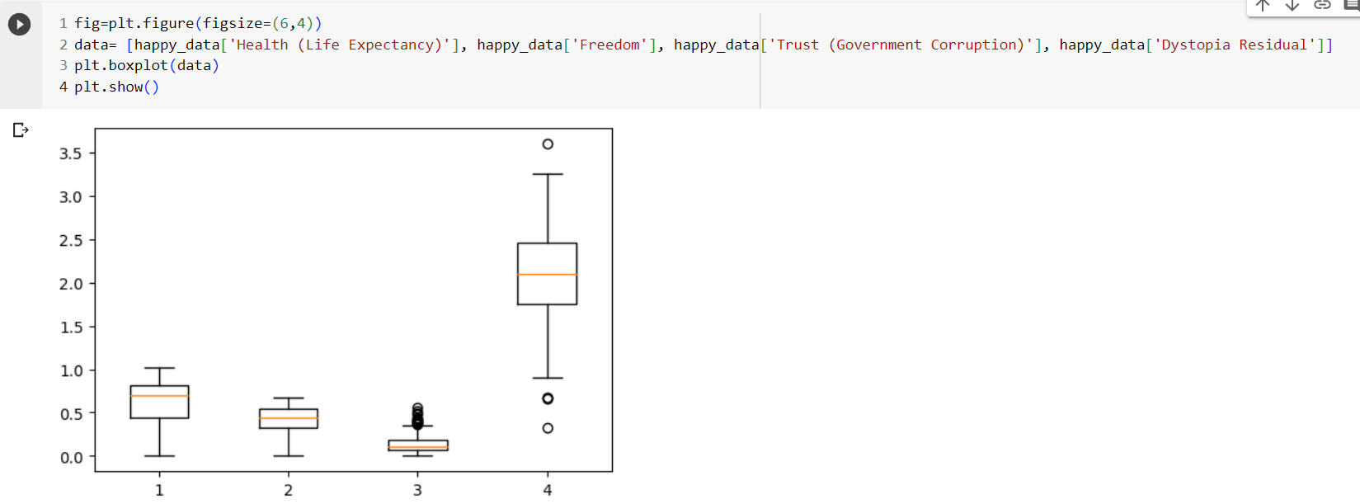

Outliers can change the result of the data analysis and statistical modelling. It may cause a significant impact on mean and the standard deviation.

Step-6: Segregate target value and removing useless columns.

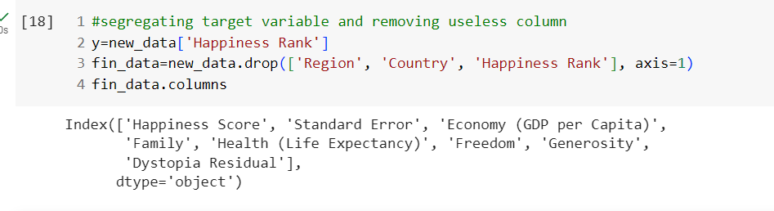

Step-7: Removing outliers from the data

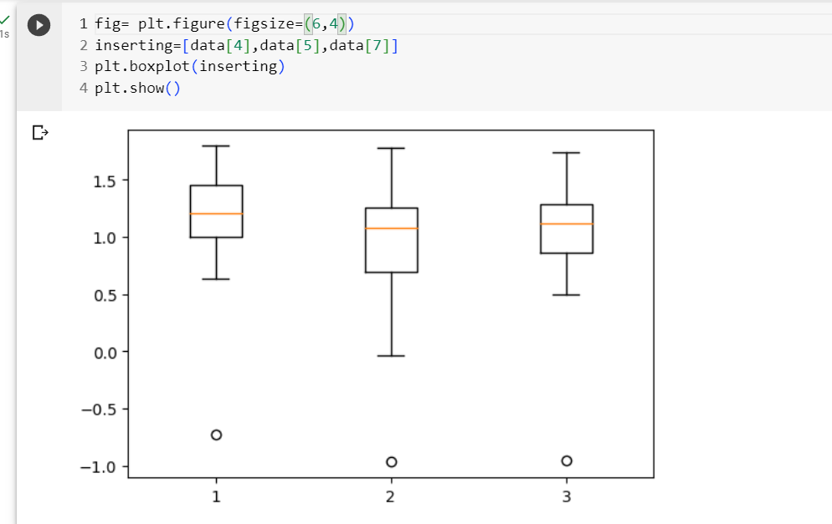

As we can observe number of outliers have diminished.

Step-8: By using machine learning model we will check the accuracy of training and testing data.

